
Perth Modern School
Semester One Examination, 2010

Question/Answer Booklet

Student Name ____SOLUTIONS__

Teachers Name ______________________
MATHEMATICS
3A/3B
Section One:
Calculator-free

Student Number: In figures

In words

Time allowed for this section
Reading time before commencing work: 5 minutes
Working time for this section: 50 minutes

Material required/recommended for this section

To be provided by the supervisor
This Question/Answer Booklet
Formula Sheet

To be provided by the candidate
Standard items: pens, pencils, pencil sharpener, eraser, correction fluid, ruler, highlighters
Special items: nil

Important note to candidates
No other items may be used in this section of the examination. It is your responsibility to ensure that you do not have any unauthorised notes or other items of a non-personal nature in the examination room. If you have any unauthorised material with you, hand it to the supervisor before reading any further.
Structure of this paper

Section | Number of questions available | Number of questions to be answered | Working time (minutes) | Marks  available
Section One:  Calculator-free | 6 | 6 | 50 | 40
Section Two  Calculator-assumed | 10 | 10 | 100 | 80
 |  |  |  | 120

Instructions to candidates

1. The rules for the conduct of examinations are detailed in the Year 12 Information Handbook 2010. Sitting this examination implies that you agree to abide by these rules.

2. Write your answers in the spaces provided in this Question/Answer Booklet. Spare pages are included at the end of this booklet. They can be used for planning your responses and/or as additional space if required to continue an answer.
  - Planning: If you use the spare pages for planning, indicate this clearly at the top of the page.
  - Continuing an answer: If you need to use the space to continue an answer, indicate in the original answer space where the answer is continued, i.e. give the page number. Fill in the number of the question(s) that you are continuing to answer at the top of the page.

3. Show all your working clearly. Your working should be in sufficient detail to allow your answers to be checked readily and for marks to be awarded for reasoning. Incorrect answers given without supporting reasoning cannot be allocated any marks. For any question or part question worth more than two marks, valid working or justification is required to receive full marks. If you repeat an answer to any question, ensure that you cancel the answer you do not wish to have marked.

4. It is recommended that you do not use pencil except in diagrams.

Section One: Calculator-free (40 Marks)

This section has six (6) questions. Answer all questions. Write your answers in the space provided.

Spare pages are included at the end of this booklet. They can be used for planning your responses and/or as additional space if required to continue an answer.
  - Planning: If you use the spare pages for planning, indicate this clearly at the top of the page.
  - Continuing an answer: If you need to use the space to continue an answer, indicate in the original answer space where the answer is continued, i.e. give the page number. Fill in the number of the question(s) that you are continuing to answer at the top of the page.

Working time available for this section is 50 minutes.

1. [11 marks]

(a) Differentiate the following functions with respect to x

(i) y = 3x⁴ – 7x² + 4x -8 [1]
✓
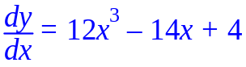
(ii) 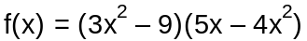 (Do NOT Simplify) [2]
✓
✓

(iii) 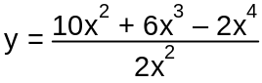 [2]
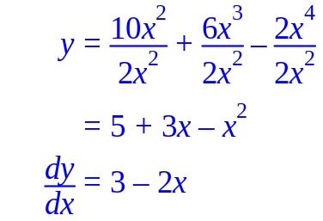
✓
✓

(b) Using calculus and algebra, determine for which value/s of x the curve

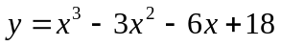 has a gradient of 3. [3]

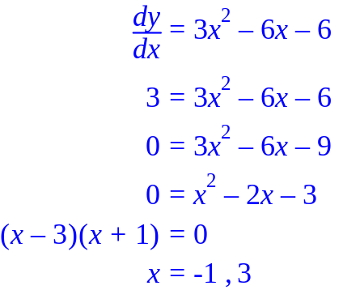
✓
✓
✓
(c) Determine the equation of the line that is a tangent to the curve 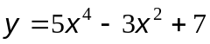 at the point where x = 1. [3]
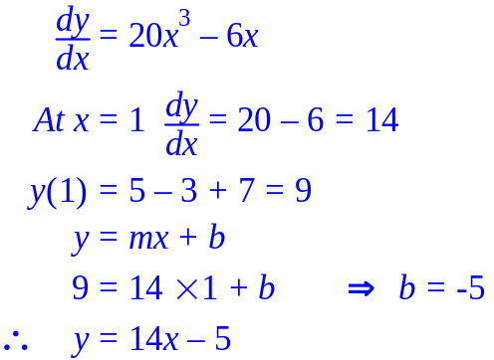
✓
✓
✓

2. [5 marks]

Use the process of anti-differentiation to find the following integrals.

(a) (i) 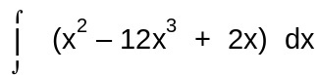 [1]

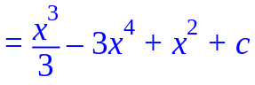
✓

(ii) 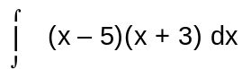 [2]

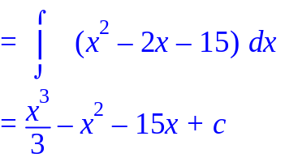
✓
✓

(b) Given 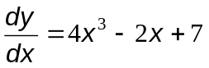 and y = 5 when x = -1, determine y as a function of x. [2]
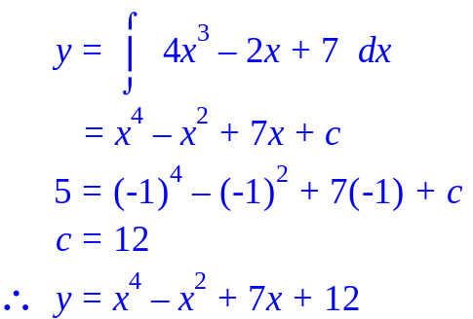
✓
✓

3. [8 marks]

a) Simplify the following and express your answers with positive indices:

(i) 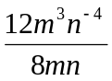 [2]

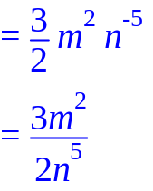 ✓
✓

(ii) 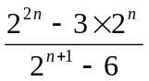 [3]

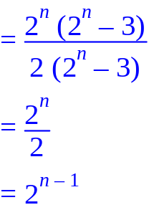
✓
✓
✓

b) Simplify, and hence solve the following equation for x. [3]

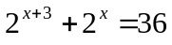

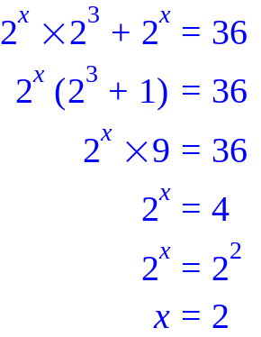
✓
✓
✓

4. [5 marks]

In a team of walkers there are 3 ladies and 4 gentlemen. None of them have the same name. They have arrived at a lunch spot and are delighted to find that there is someone there who agrees to take a group photo for them. They decide to make two rows in the photo, the ladies crouching down in the front with the gentlemen standing behind.

Determine the following leaving your answer in factorial form:

(a) How many different arrangements are there for the back row? [1]

4! ✓

(b) How many different arrangements are there for the front row? [1]

3! ✓

(c) How many different arrangements are there for the photo? [1]

4! × 3! ✓

(d) How many different arrangements are there if Jane must stand next to Mary and Craig next to Daniel? [2]

3! × 2 × 2! × 2 ✓✓

5. [5 marks]
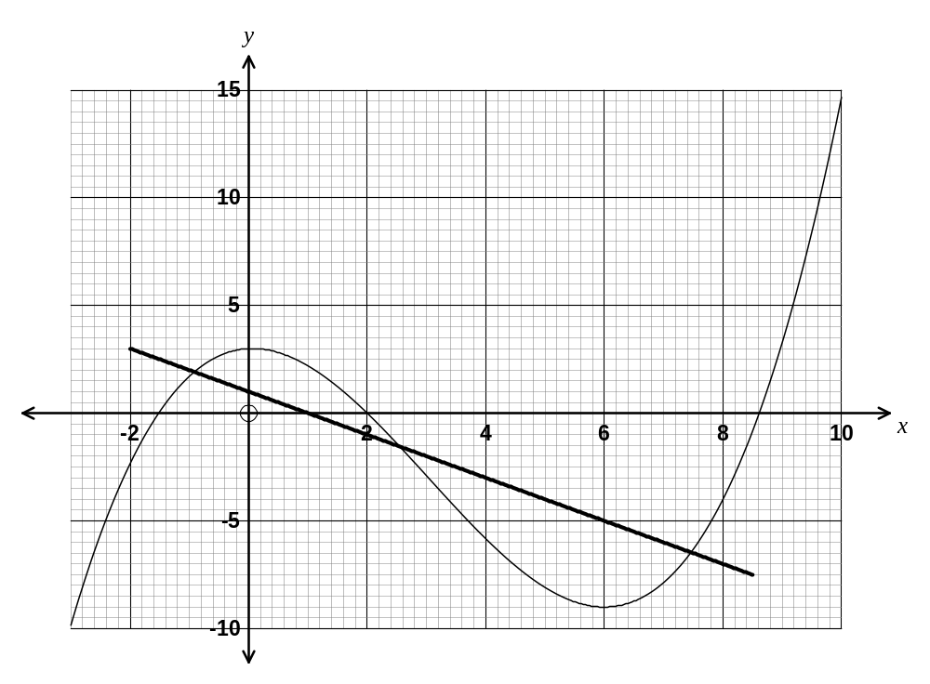
The diagram below shows the graph of .

✓ identifies correct y-intercept on graph
✓ draws graph with correct slope

(a) The equation , where is an integer, has exactly two distinct real solutions.
Use the graph to find the possible values of . [1]

k = 3 or -9 ✓✓ 1 mark for each value

(b) For what values of does the graph of appear to have a negative gradient?
[1]
0 < x < 6 ✓ states correct interval

(c) The equation can be solved by drawing a line on the graph.

(i) Draw and label this line on the graph. [2]

(ii) How many solutions are there for ? [1]

3 ✓ determines number of solutions

6. [6 marks]
(a) Fraser is an amateur magician. He asks each member of the audience to chose a number, then to

    - Add 1
    - Multiply that answer by 2
    - Add 6
    - Divide by 2
    - Finally to take away the number you started with

He then tells them that the answer is 4, regardless of what number you started with.

- Verify that this works for a starting number of 12 [1]
12
12 + 1=13
13 x 2 = 26
26 + 6 = 32 ✓
32 ÷ 2 = 16
16 – 12 = 4
This means it works for a starting number of 12

- Verify that this works for a starting number of (-1) [1]
-1
-1 + 1=0
0 x 2 = 0
0 + 6 = 6 ✓
6 ÷ 2 = 3
3 – (-1) = 4
This means it works for a starting number of -1

- Prove that Fraser’s trick is not magic. [2]

Start with the number n
Add 1 n + 1
Multiply by 2 2(n + 1) ✓
Add 6 2(n + 1) + 6
Divide by 2 n + 1 + 3 = n+4 ✓
Subtract n 4 ✓
- 1 + 2 + 3 =6
The number 6 is divisible by three
Prove that the sum of any three consecutive whole numbers is divisible by 3 [2]
Let the three numbers be n, n + 1 and n + 2
Sum = n + n + 1 + n + 2
= 3n + 3
= 3 ( n + 1)
Which is divisible by 3

✓✓ Logical Proof

Additional working space

Question number(s): _____________

Additional working space

Question number(s): _____________

